2nd Delivery

Eduardo Alarcón & Alfonso Pineda

2022-11-20

library(readxl)  
SpotifySongs <- read_excel("songstats.xlsx")

# Model Fitting.

By just watching the histogram, we can suppose that our main variable, the energy, will follow a normal distribution

SpotifySongs <- read_excel("songstats.xlsx")  
suppressWarnings(library(summarytools))   
energy <- SpotifySongs$energy  
descr(energy)

## Descriptive Statistics   
## energy   
## N: 167   
##   
## energy  
## ----------------- --------  
## Mean 660.92  
## Std.Dev 185.68  
## Min 104.00  
## Q1 551.00  
## Median 667.00  
## Q3 804.00  
## Max 993.00  
## MAD 188.29  
## IQR 249.50  
## CV 0.28  
## Skewness -0.44  
## SE.Skewness 0.19  
## Kurtosis 0.07  
## N.Valid 167.00  
## Pct.Valid 100.00

hist(energy, probability = TRUE, xlab = "Energy")  
curve(dnorm(x, mean(energy), sd(energy)), col="blue", lwd=2, add=TRUE, yaxt="n")

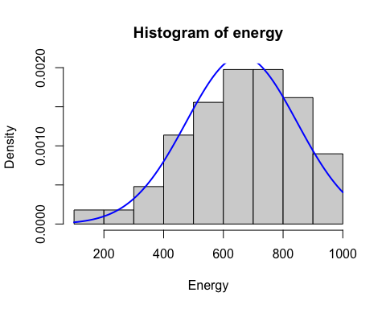

Partition <- hist(energy, plot=FALSE)  
Partition

## $breaks  
## [1] 100 200 300 400 500 600 700 800 900 1000  
##   
## $counts  
## [1] 3 3 8 19 26 33 33 27 15  
##   
## $density  
## [1] 0.0001796407 0.0001796407 0.0004790419 0.0011377246 0.0015568862  
## [6] 0.0019760479 0.0019760479 0.0016167665 0.0008982036  
##   
## $mids  
## [1] 150 250 350 450 550 650 750 850 950  
##   
## $xname  
## [1] "energy"  
##   
## $equidist  
## [1] TRUE  
##   
## attr(,"class")  
## [1] "histogram"

library(fitdistrplus)

## Loading required package: MASS

## Loading required package: survival

normalfit <- fitdist(energy, "norm")  
normalfit

## Fitting of the distribution ' norm ' by maximum likelihood   
## Parameters:  
## estimate Std. Error  
## mean 660.9222 14.32480  
## sd 185.1206 10.12919

CummulativeProbabilities = pnorm(c(-Inf, Partition$breaks[c(-1, -10)], Inf),  
 normalfit$estimate[1], normalfit$estimate[2])  
Probabilities = diff(CummulativeProbabilities)  
Expected = length(energy)*Probabilities  
chisq.test(Partition$counts, p=Probabilities)

## Warning in chisq.test(Partition$counts, p = Probabilities): Chi-squared  
## approximation may be incorrect

##   
## Chi-squared test for given probabilities  
##   
## data: Partition$counts  
## X-squared = 5.9441, df = 8, p-value = 0.6535

pchisq(5.9441, 6, lower.tail = FALSE)

## [1] 0.4294811

As we can see from the previous test, the normal distribution model can be used as the p-value is less than 0.05. We can confirm this data by using the following texts

library(nortest)  
ad.test(energy)

##   
## Anderson-Darling normality test  
##   
## data: energy  
## A = 0.46126, p-value = 0.2563

cvm.test(energy)

##   
## Cramer-von Mises normality test  
##   
## data: energy  
## W = 0.053358, p-value = 0.4607

lillie.test(energy)

##   
## Lilliefors (Kolmogorov-Smirnov) normality test  
##   
## data: energy  
## D = 0.040216, p-value = 0.7325

pearson.test(energy)

##   
## Pearson chi-square normality test  
##   
## data: energy  
## P = 10.725, p-value = 0.6339

sf.test(energy)

##   
## Shapiro-Francia normality test  
##   
## data: energy  
## W = 0.98224, p-value = 0.03169

plot(normalfit)

